SOLUTIONS

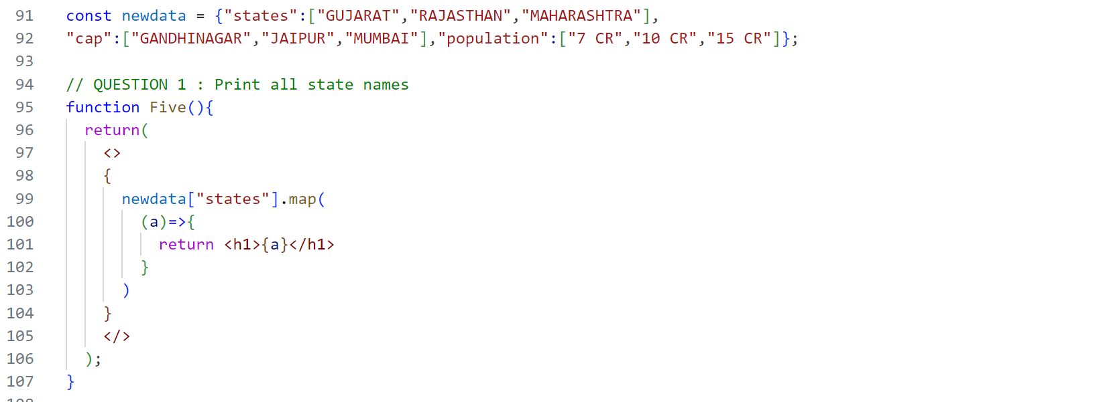

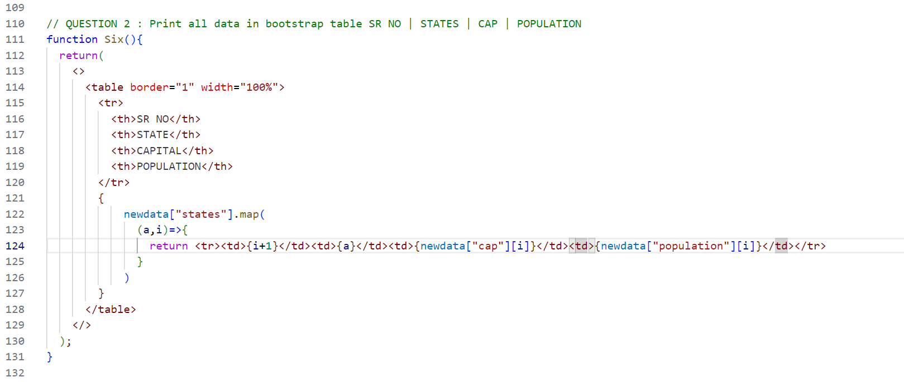

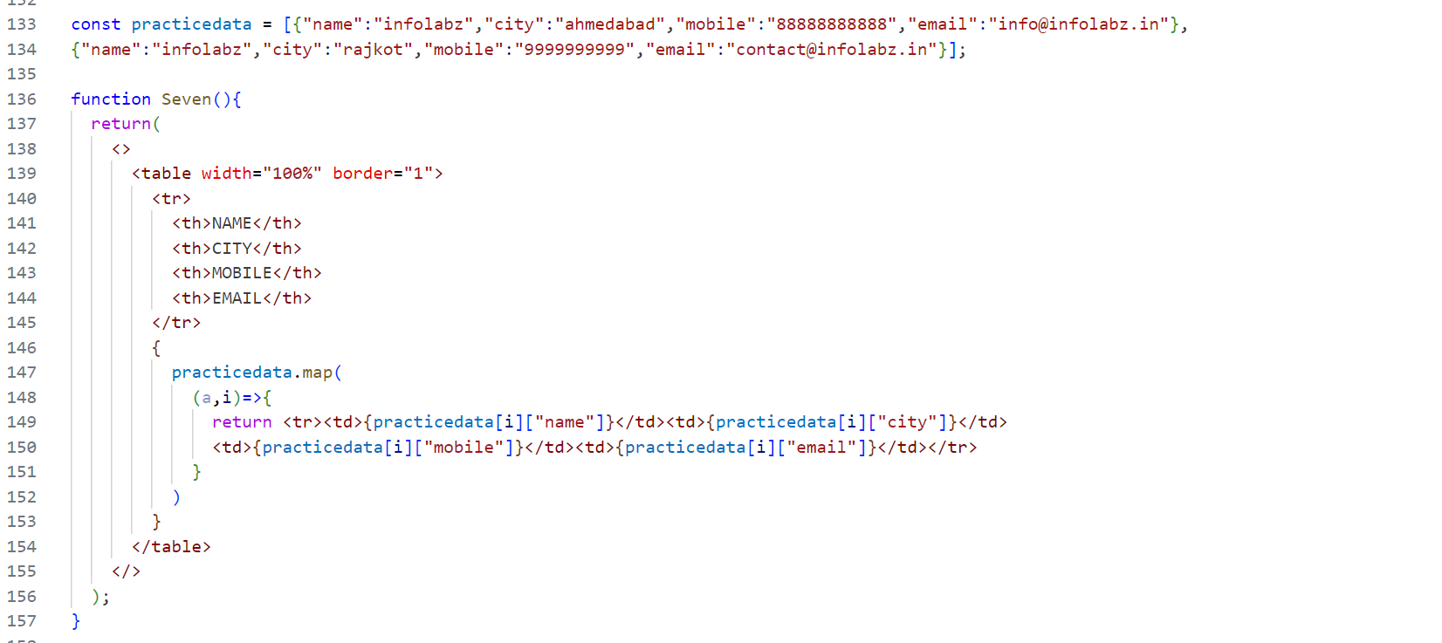

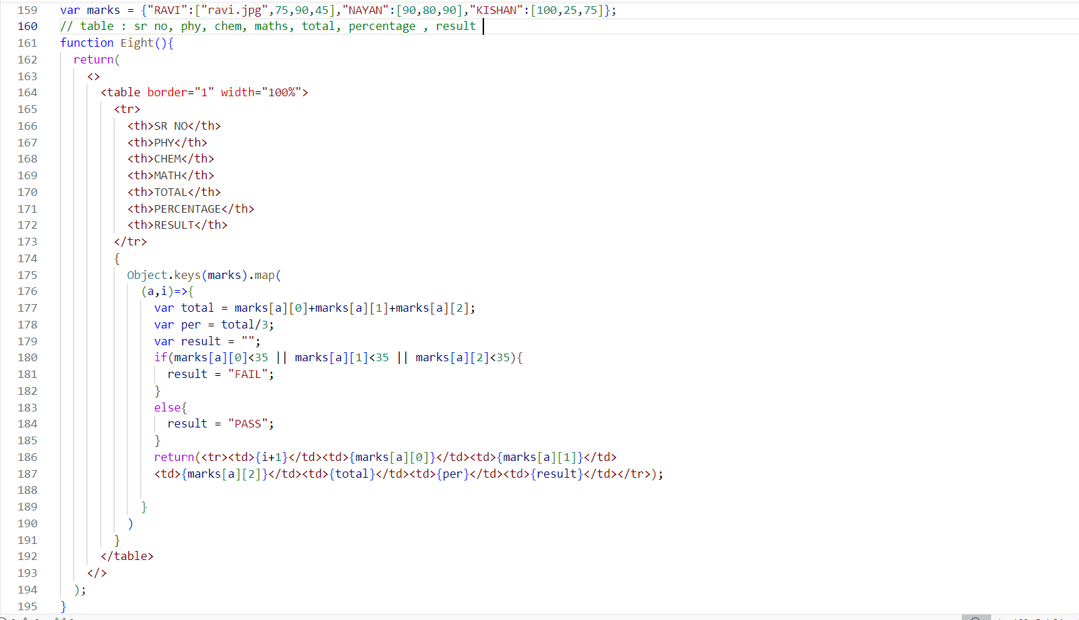

// SR NO | NAME | PHOTO (ROUNDED CIRCLE ) | PHY | CHEM | MATH | TOTAL | PER | RESULT ( BADGE PASS GREEN FAIL RED )

// DEVELOP ONE API WITH REF OF ABOVE API INCLUDE PATH OF PHOTO IN API AND STORE IMAGE IN SOME FOLDER => 3 Images

**REACT PROPS + MAP**

var datamap = [{"emp_name":"Ravi","emp_tech":"Python","emp_exp":"2 years"},

{"emp_name":"Nayan","emp_tech":"Flutter","emp_exp":"3 years"}];

Print above data inside simple h1 tag

var students = [{"name":"ravi","physics":75,"chemistry":85,"maths":100,"pic":"a.png"},

{"name":"nayan","physics":55,"chemistry":95,"maths":80,"pic":"b.jpg"}];

Print above data inside table :

SR NO | NAME | PHYSICS | CHEMISTRY | MATHS | IMAGE

**APPLY PROPS + MAP INSIDE TEMPLATE**

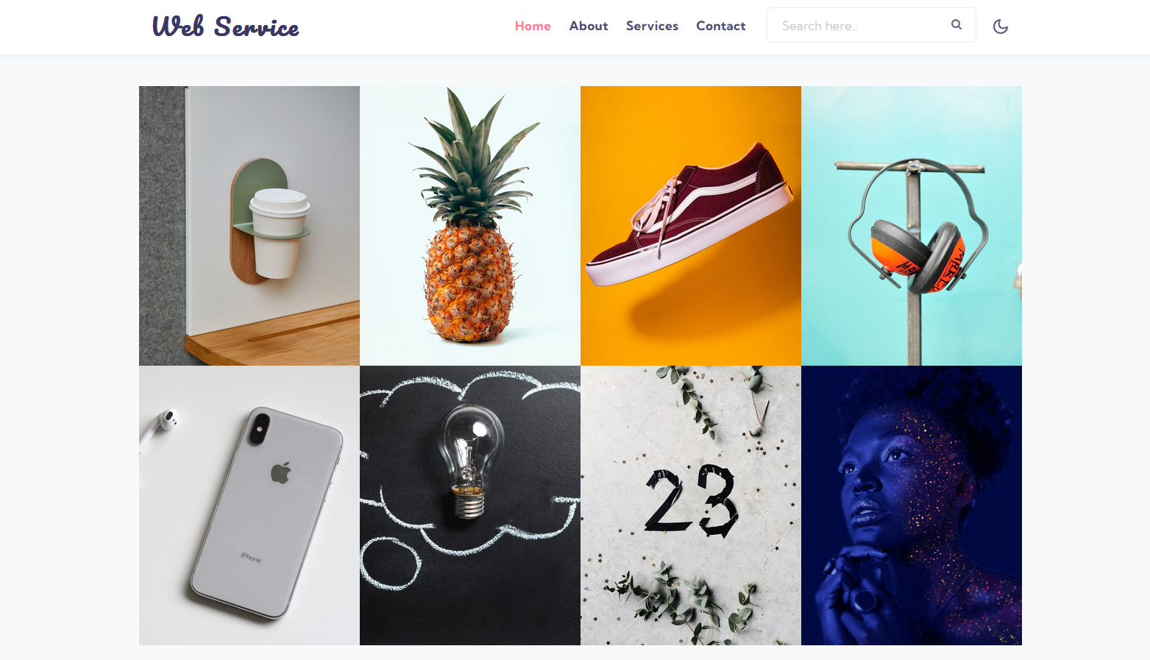

Create variable of Image, Title, Description and print above data using props and maps